# Running in ‘default’ environment

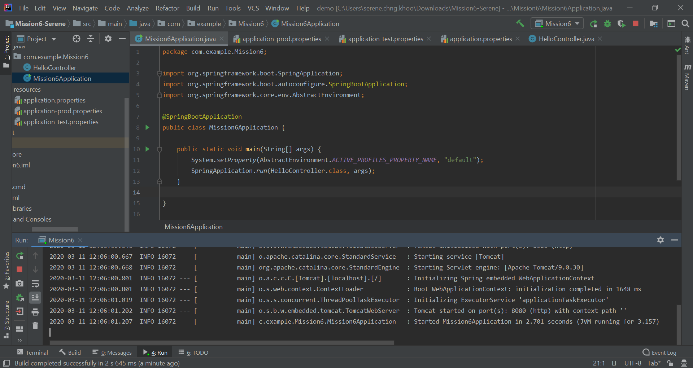

Application class codes.

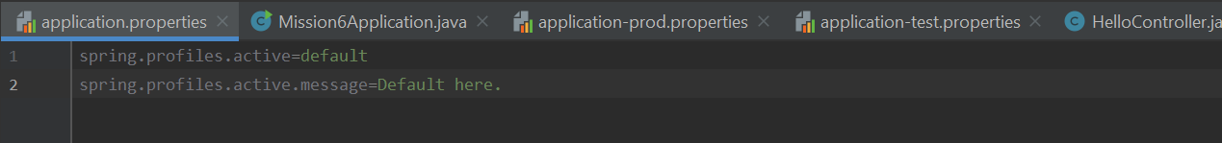

application.properties resource bundle codes.

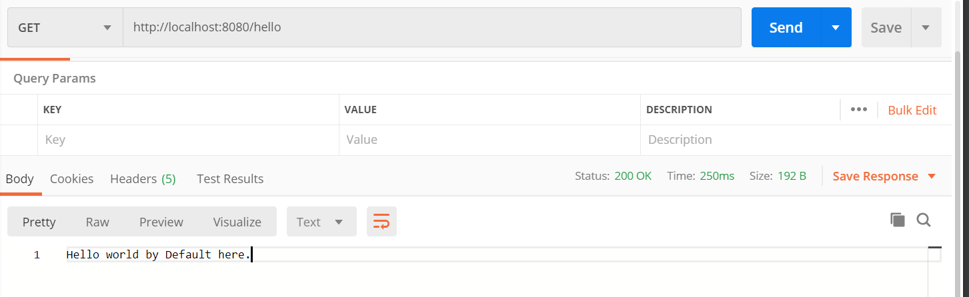

Result in postman.

# Running in ‘test’ environment.

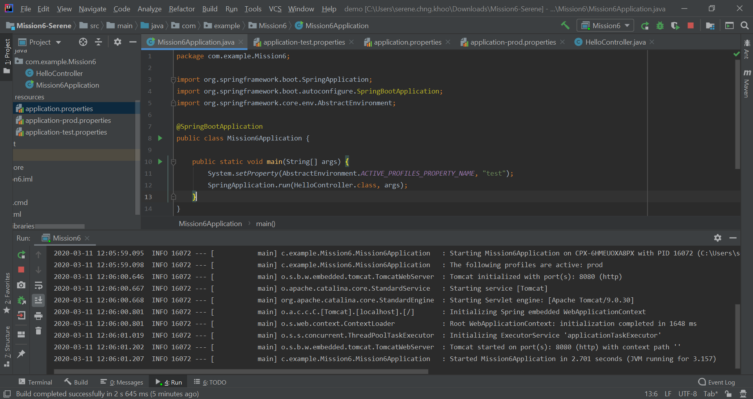

Application class codes.

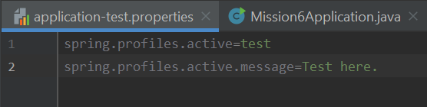

application-test.properties resource bundle codes.

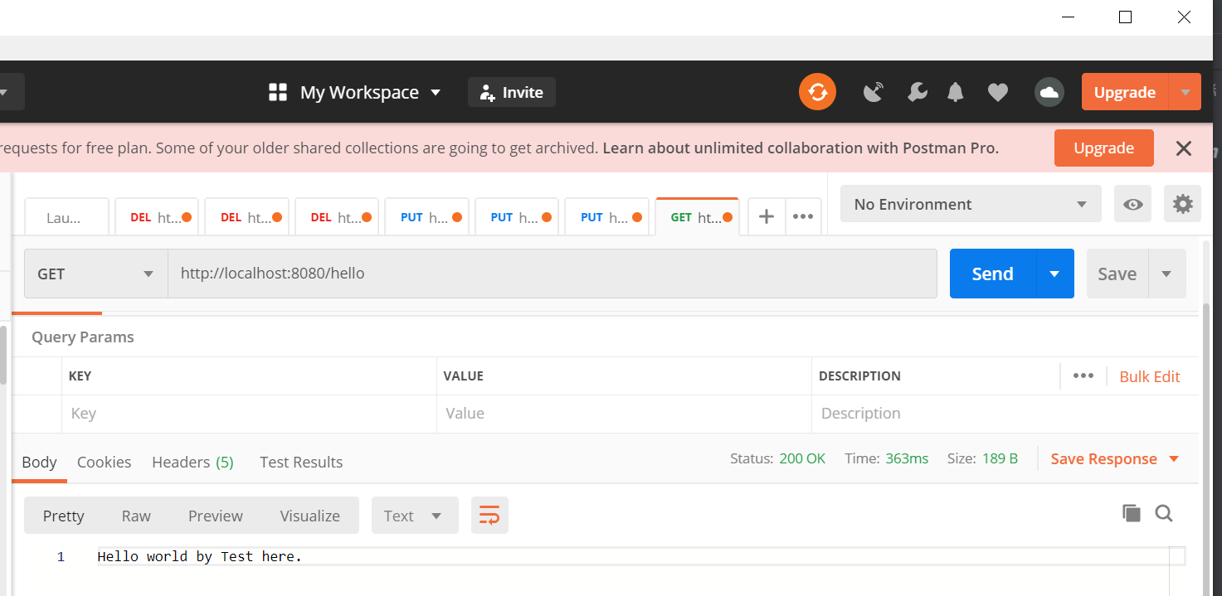

Result in postman.

# Running in ‘prod’ environment.

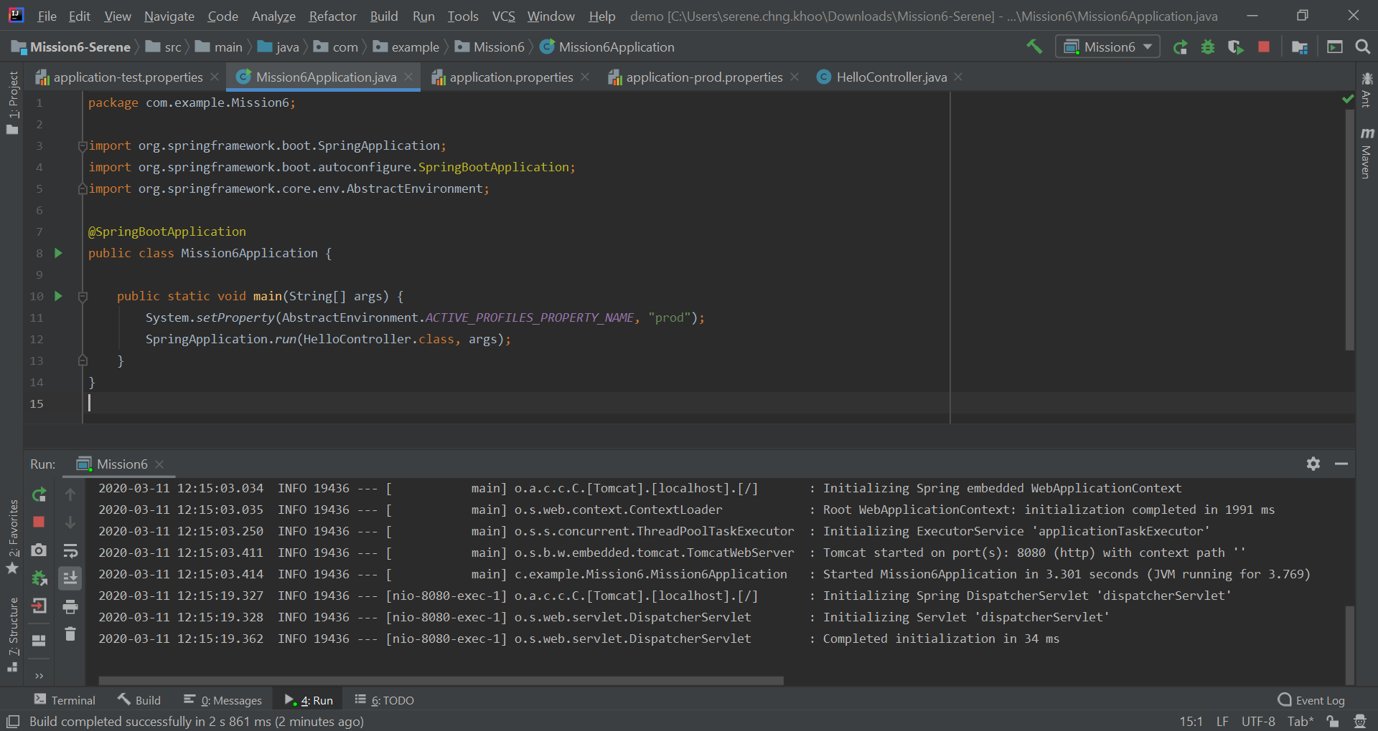

Application class codes.

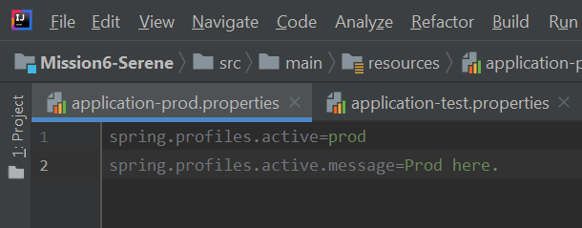

application-prod.properties resource bundle codes.

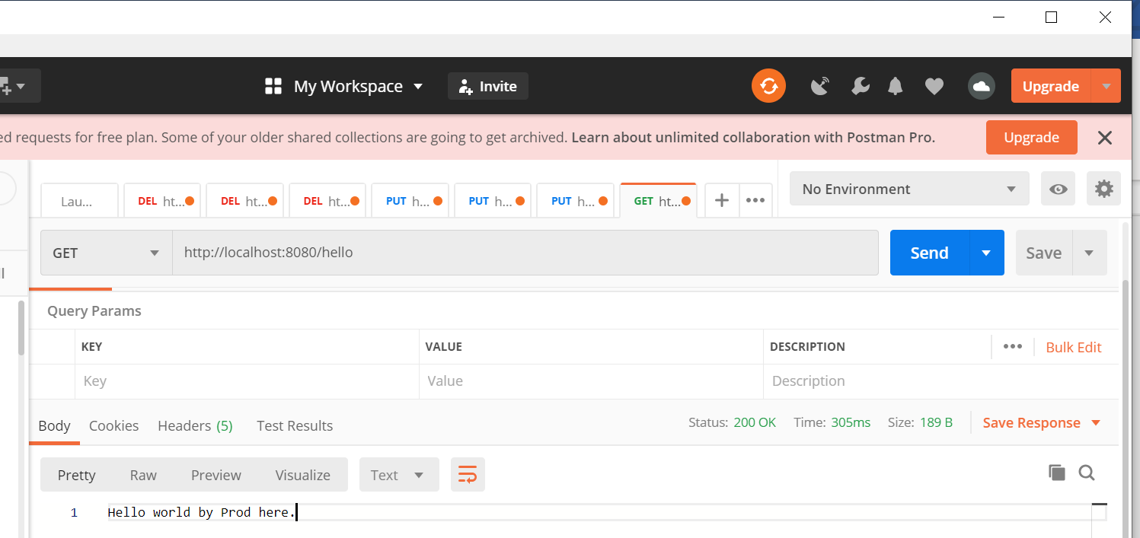

Result in postman.